The Tapestry at St Nicholas Priory Exeter, 1982
(from a report by Alan Quincey, 2001.)

Summary;
An exhibition of member’s work was held at the Royal Albert Memorial Museum in Exeter in 1981. Membership increased in the Guild following the interest in the exhibition (200+). Joyce Cook (chairperson) suggested a joint project to integrate members in this large group. Pat Johns (Guild member and designer and maker of tapestry) approached the Museum who suggested (and funded) a tapestry for St Nicholas Priory in Exeter.

The tapestry comprised 5 panels illustrating 5 legendary episodes in the life of St Nicholas (a bishop at Myra in the early 4th century). At the top of each panel a dramatic interpretation of the roof timbers of the Priory Great Hall; beneath the pictorial roundals on the outer 4 panels a pattern of colour lozenges.

6 fleeces were washed, dyed, spun and plyed by different members, weaving frames were built. The final panels were joined and the whole tapestry lined.
61 members were involved from start to finish with a total of 10000 hours of member’s time.

The final tapestry measured 14ft wide by 8ft high and was officially presented to the Priory on December 4th 1982 by the Guild president Edith Gaskell.

From the Jan 1993 newsletter, an excerpt from a letter from Jeremy Pearson, Curator of Applied Arts, Royal Albert Museum, Exeter;
“I have already received a number of complimentary comments about the tapestry – both for it’s design, colour and excellence of workmanship – and I feel sure that it will enhance the already high reputation of the Guild”.

(see pictures below and separate page)
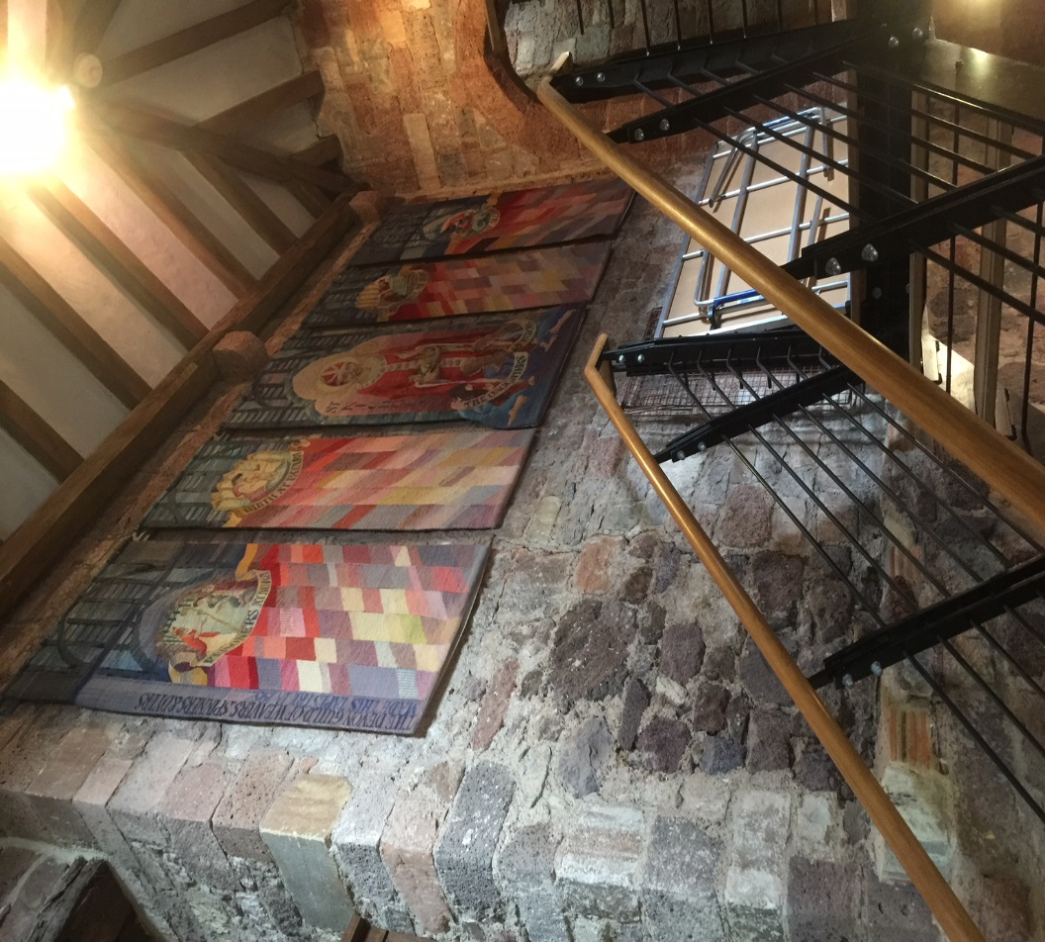
The tapestry in it’s present location (July 2018) at the top of the stairs, note it is hung as 5 separate panels.

St Nicholas Priory is open 1-4pm on Sunday afternoons and is free to enter.

It is well worth a visit, even though the tapestry is now 35 years old the colours are fresh and vibrant and the quality is excellent.

