Batts | Carded hunks of fibre as it comes off of a drumcarder
Bobbin | The shaft of the spool onto which the spun yarn is wound on a spinning wheel
Blending Board |  | 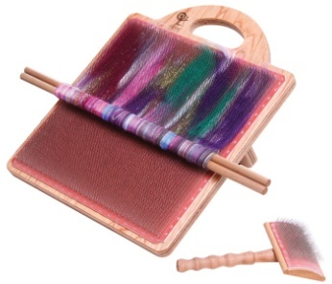
Carders | A pair of brushes used to smooth and straighten fibres for spinning | 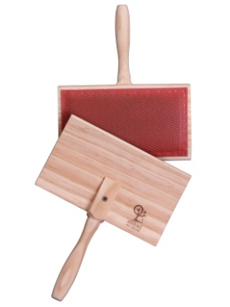
Combs | Used to process long stapled wool for worsted spinning | 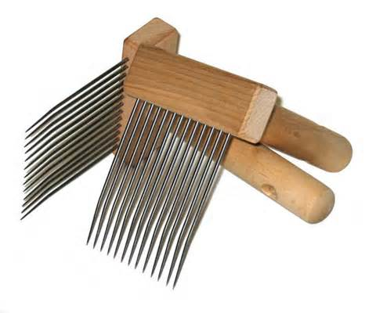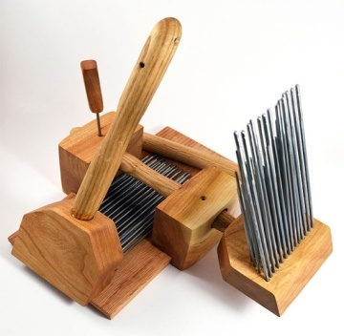
Crimp | Amount of curl in a lock of fleece; fine wool is very crimpy
Distaff | A staff that holds the flax or wool fibres which are drawn from as the spinner needs them when spinning. A distaff can be attached to a belt, mounted on the bench of a spinning wheel, or freestanding.
Doffer Brush
Doffer Stick |  | 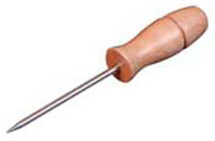
Draft | The pulling out of fibres to allow only a certain amount of the fibre to twist into thread
Drafting triangle | The space between the spun yarn and the fibres being drawn out
Drive band | The cord carrying the power from the large wheel to the spindle or bobbin/pulley
Spindle | Drop spindle  (Handspindle) a stick with a weighted whorl that is used to twist fibres into thread | 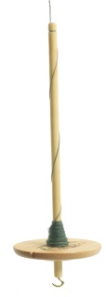
 | Supported spindle
 | Turkish spindle | 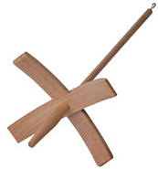
Drum Carder |  | 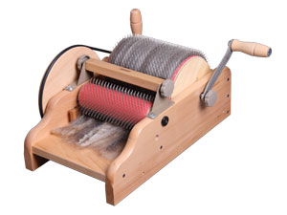
Ewe | A mature female sheep
Fibre | Unspun hair, wool or plant material
Fleece | The entire coat of wool from a sheep
Flick Carder |  | 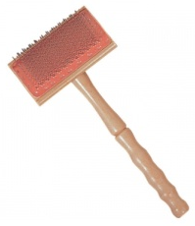
Flyer | The U shaped device on a treadle spinning wheel that twists the yarn
Footman | The straight piece of wood or wire that connects the treadle to the axle/crank of a spinning wheel
Hackle |  | 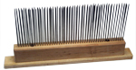
In the Grease | Unwashed wool, straight from the sheep
Lazy Kate |  | 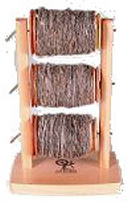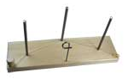
Maidens | (Or sisters) two upright pieces of wood that hold the spinning apparatus in a horizontal position
Mother of All | Usually, the entire spinning mechanism on a spinning wheel; maidens, flyer and bobbin
NiddyNoddy | Doubleheaded tool used in skeining spun yarn | 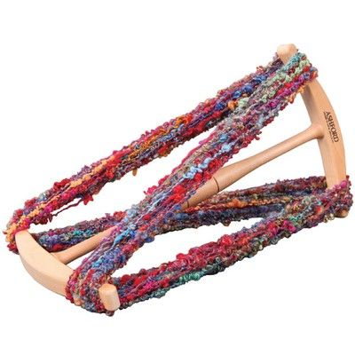
Noils | Short fibres removed when combing the fleece; can be mixed with other wool and carded and spun
Orifice | The opening or eye of the spindle on a treadle spinning wheel
Pencil roving | Thinner strips of roving roughly the diameter of a pencil
Picker |  | 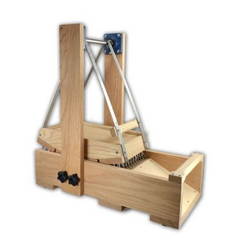  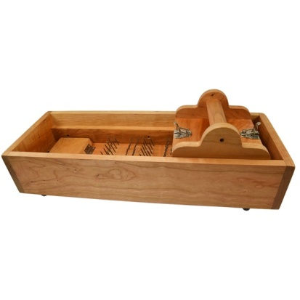
Plying | Winding two or more yarns together; must be done in the opposite direction to that in which they were spun
Punis | A used for short-medium stapled fibres which was originally used only for cotton.is carded and blended on hand carders then rolled tightly around a stick or knitting needle. | 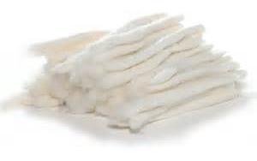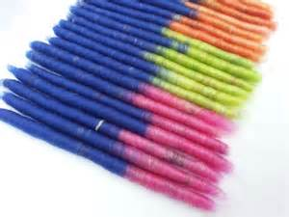
Rolag | Roll of carded wool, ready for spinning to make woolen yarn
Roving | Long tubes of carded wool, produced by carding machines
Stwist | Yarn spun with a counterclockwise twist
Scour | To wash or clean fibres or spun yarns
Skeining | Winding yarn off the spindle
Skirted fleece | Grease wool that has had the dirty edges removed all the way around
Sliver | Strips of batts in one continuous strip
Slub | The flaw or fat place in the yarn (sometimes intentionally spun in for novelty yarns) note: the length of a slub cannot be longer than the staple of a fibre
Spindle pulley | The small grooved whorl that carries the drive band connecting the spindle to the drive wheel
Staple | Length of a lock of fleece or a single fibre
Strick | A bundle of flax prepared for spinning after the tow has been removed (long fibres only)
Tops | Long fibres straightened by combing
Tow | The short fibres left after flax is combed out
Treadle | The foot pedal that turns the main wheel, or the process of pushing the pedal of the main wheel
Whorl | The weighted part of a drop spindle that helps it to spin. Also the spindle pulley that regulates the speed of a spinning wheel spindle
Woolen | Yarns made from shortstapled wool; has a soft finish and felts well
Worsted | Made from longstapled wool where the fibres are combed lengthwise and spun from cut end to tip in appareltype fashion; has a firm finish and does not usually felt (i.e. Most tweeds, suit or jacket material)
Z twist | Yarn spun with a clockwise spin with z twist
Parts of a Spinning Wheel (Craftsy)

